Steps to setup localization/translations for this project

Basic Setup
- Open the Localization Dashboard from here!
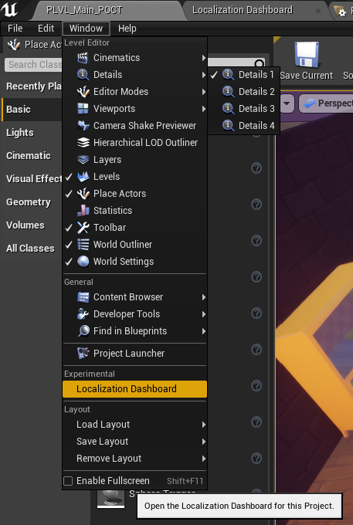
- Make sure all contexts for translation are stored inside this folder Content/Tables/LocalizationTables.

For now there is only one file called TABLE_UIContent, but more tables could be created for various reasons (tutorials, instructions, anything context related e.t.c.)

Only include the original English content in this folder (exceptions are contexts displayed in other languages for language instructions, like 中文, 日本語, Español)
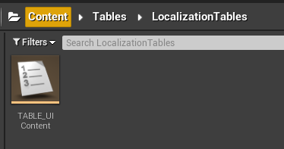
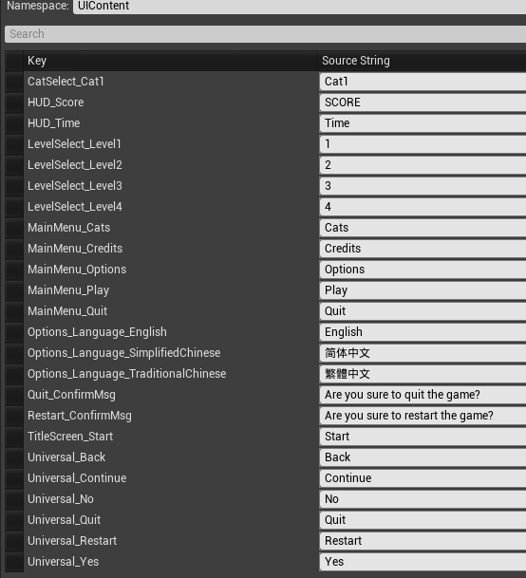
- For text which needs to be displayed for localization, it needs to be set to load from the string table.
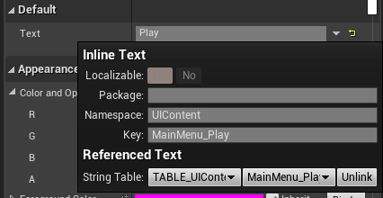

Start Translation
- Open the Localization Dashboard, check out DefaultEditor.ini.
- This panel is the main panel for translation. Click on Add New Culture to set up a new language for the project.
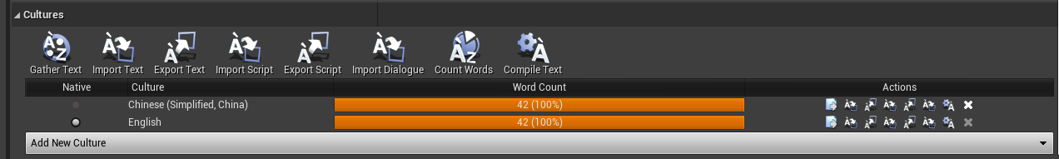
- The basic workflow will be Gather Text -> Translating -> Count Words -> Compile Text -> Gather Text (again!)
  - Gather Text: Just click on Gather Text and the system will automatically collect the text for translation.
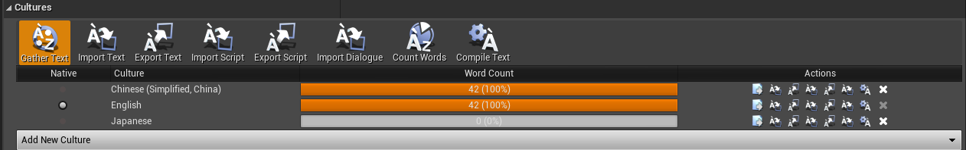
So after clicking on that button, the panel Word Count will display the remaining context for translation in that specific language.
  - Translating: Click on this button, and a detailed translation panel will appear here. The two tabs we care about are Untranslated and Completed. In Untranslated tab, you can see all contexts which haven’t been translated, and you can just simply type in the translations in this sheet. In completed tab, the contexts are fully translated and have been built into the game.
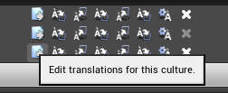
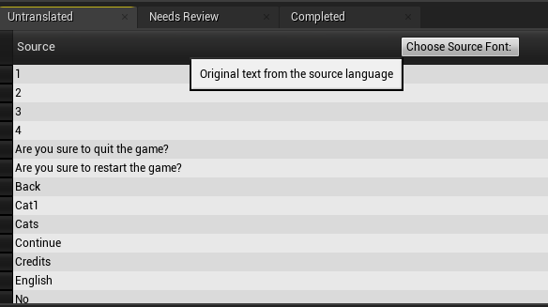
  - Count Words & Compile Text & Gather Text: After translating the contexts, the translations won’t be automatically built into the game, you need to compile to get those translations from Untranslated to Completed.
- Now if you see 100% in the Word Count tab, that means you correctly finished the translations for that language!

For Debug
- Make sure the game is running in Standalone Game Mode, if you just play it in the editor and try to switch languages,
THE WHOLE UNREAL ENGINE WILL SWITCH THE LANGUAGE!!!!!
(If your engine accidentally changed the language and you have no idea how to deal with it, please find a SD for help.)

